Phonics lesson plans – unstressed er

DAY | We Are Learning To (WALT): | MODEL / INTRODUCTION | INDEPENDENT WORK | PLENARY
 | Recognise, read and spell er in words | Go through flashcards for today’s high frequency words  Revise the graphemes (letter strings) that we have covered previously – show children clue cards with each grapheme on the front and a clue word on the back. Have them say the clue word, then the sound that the grapheme represents e.g. bat, (b)  Read children a story which contains today’s grapheme – the story of The Super Runner (without letting them see the story)  Read children the story again, this time telling them to listen for which phoneme (sound) they hear most often in the story  Ask children to think, pair, share some of the words that contain today’s phoneme that they heard in the story  Ask children where the sound comes in the words i.e. at the beginning of the word, in the middle of the word or at the end of the word, or in more than one position  Show children the story on the IWB  Read the story again, asking the children to spot which letters are used to represent the sound in the story  Ask children to tell their partner which letters are used to represent the sound  Have children repeat this phrase – ‘E R can represent (ə)’  Repeat this phrase several times in different ‘voices’ e.g. loudly, quietly, quickly, slowly etc | Lower ability – circle the correct word (from a choice of 3 words) under a picture  Middle ability – join the correct letters together to make the word to go with a picture e.g.  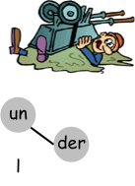  Higher ability – unscramble the letters to make the correct word to go with a picture e.g.  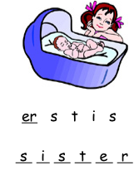  Extension – complete a Wordsearch with words with today’s grapheme | Revise the phrase for today: ‘E R can represent (ə)’  Ask children to think, pair, share as many of the words from today’s lesson as they can  Complete the additional IWB activities e.g. match the word and image and / or guess the missing word

© www.SaveTeachersSundays.com 2013

